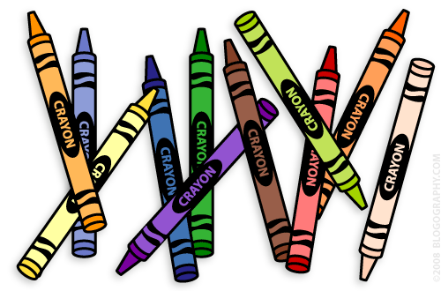**Our 1st Grade Classroom News**

**The Week of Sept. 26th – 30th**

**Email:** [**Lweeks@bluevalleyk12.org**](mailto:Lweeks@bluevalleyk12.org)

**Website:** [**www.bluevalleyk12.org/hes/lweeks**](http://www.bluevalleyk12.org/hes/lweeks)

* Thank you all so much for helping your child get ready for our zoo field trip! A special thank you to all of the zoo volunteers! It was a SUPER successful field trip because of all of you!

We will be reviewing all of the short vowels this week.

Just a heads up, the week of October 17th students will be asked to bring a pumpkin to school. It can be any size as long as they can carry it (even mini pumpkins work). We are going to have a Pumpkin Theme Week! Students should NOT bring any pumpkin before October 17th.

**Important Info**

Oct. 3rd Reading logs are due   
Oct. 4th Early Release Day  
Oct. 7th Walk-a-thon 9-10am on HMS Track

Oct. 14th No School

**Upcoming Events**

**Website of the Week:** GoNoodle is a great website to get your child active and moving around! We use this website almost every day as a brain break. Students can pick different activities that get them moving! Once they have achieved a certain amount of activities, they can go to another level! The activities are around 4 minutes so this is a great way to get their energy out quickly! [www.gonoodle.com](http://www.gonoodle.com)

**App of the Week:** [Solar Walk](http://itunes.apple.com/us/app/solar-walk-3d-solar-system/id347546771?mt=8)is an AMAZING app that shows students what planets actually look like up close and gives them information about them!

**Math Challenge of the Week:**Last week we focused on how to turn a number sentence around and talked about how it means the same thing when doing that. For example, we turned 8-3=5 into 5=8-3. To do this, we simply moved the = sign and the number that it equals to the front of the problem. The rest of the problem stays the same. Have your child come up with 5-10 subtraction problems and have them flip it around. See below for another example:   
 9 - 4 **= 5**  
 **5 =** 9 - 4

**Reading Challenge of the Week:** Last week we worked on sequence of events in a story. We talked about how important it is that a book keeps the sequence in order because the story may not make sense otherwise. Have your child read a book and write down the sequence of events after that. What happened first? Next? Then? Last?

**Writing Challenge of the Week:**We have been talking a lot about fall and what it looks and feels like. Have your child come up with a story (true or not true) about themselves during the fall. For example, they may write a story about building a leaf pile with their dad. Or they can talk about going to recess and collecting leaves that had fallen off of the trees. Or they can talk about going outside while it was cold.

**Challenges of the Week**

**Tech of the Week**